Лабораторная работа № 24

**Тема:** разработка игрового проекта “ Circle”

**Цель:** приобрести навыки в разработке игрового проекта “Circle”

**Ход работы:**

Выполнение работы

Импортирование ресурсов игры

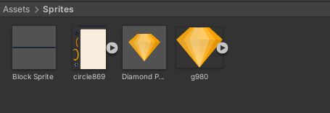

Рис. 24.1 – Папка Sprites

Создаем родительский объект Player с дочерними объектами dead Collider2D.

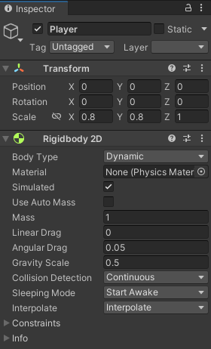

Рис. 24.2 – Player

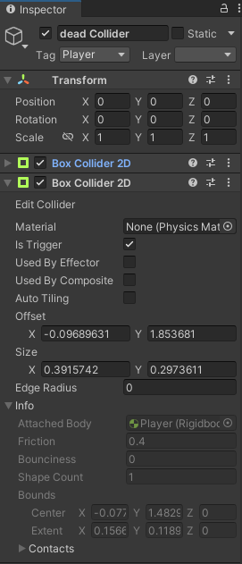

Рис. 24.3 –dead Collider

Создаем объекты Block и Diamond после чего делаем из них префабы и расставляем на сцене

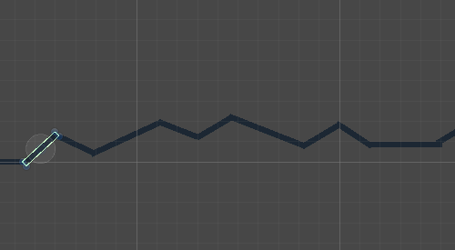

Рис. 24.4 – Prefab Block

Организация UI

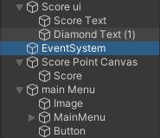

Рис. 24.5– объекты UI

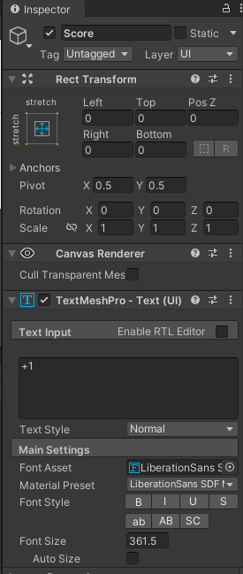

Рис. 24.6– Inspector Score

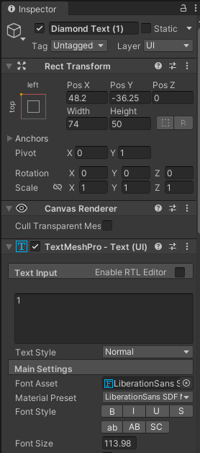

Рис. 24.7 –Diamond Text

Разработка геймплея игры

Листинг 24.1 Player.cs

|  |
| --- |
| using UnityEngine;  public class Player : MonoBehaviour  {  public Vector2 jumpForce;  Vector2 currentVelocity;  Rigidbody2D rgbd;  GameManager gameManager;  ScoreUI scoreUi;  // Start is called before the first frame update  void Start()  {  rgbd = GetComponent<Rigidbody2D>();  rgbd.gravityScale = 0;  gameManager = FindObjectOfType<GameManager>();  scoreUi = FindObjectOfType<ScoreUI>();  }  // Update is called once per frame  void Update()  {  if (gameManager.gameOver) { rgbd.bodyType = RigidbodyType2D.Static;return; }  if (Input.GetMouseButtonDown(0))  {  if (rgbd.gravityScale != 0.5f) { rgbd.gravityScale = 0.5f; }  rgbd.AddForce(jumpForce);  SpeedController();  scoreUi.IncrementScore(1);  }  }  void SpeedController()  {  currentVelocity = rgbd.velocity;  currentVelocity.x = Mathf.Clamp(currentVelocity.x, 2, 2);  currentVelocity.y = Mathf.Clamp(currentVelocity.y, 0, 2);  rgbd.velocity = currentVelocity;  }  } |

Листинг 24.2 Camera Controller.cs

|  |
| --- |
| using System.Collections;  using System.Collections.Generic;  using UnityEngine;  public class CameraController : MonoBehaviour  {  public Transform playerTransform;    void Update()  {  transform.position = new Vector3(playerTransform.position.x, transform.position.y, -10);  }  } |

Листинг 24.3 Block.cs

|  |
| --- |
| using System.Collections;  using System.Collections.Generic;  using UnityEngine;  public class Block : MonoBehaviour  {    public void OnTriggerEnter2D(Collider2D collision)  {  if(collision.tag == "Player")  {  Debug.Log("hit by player");  FindObjectOfType<GameManager>().gameOver = true;  }  }  } |

Листинг 24.4 GameManager.cs

|  |
| --- |
| using System.Collections;  using System.Collections.Generic;  using UnityEngine;  public class GameManager : MonoBehaviour  {  public bool gameOver;  } |

Листинг 24.5 Diamond.cs

|  |
| --- |
| using System.Collections;  using System.Collections.Generic;  using UnityEngine;  public class Diamond : MonoBehaviour  {  public void OnTriggerEnter2D(Collider2D collision)  {  if(collision.tag== "Player")  {  //add points  FindObjectOfType<ScoreUI>().IncrementDiamond(1);  FindObjectOfType<ScorePointCanvas>().DiamondHit(collision.transform.position);  Destroy(gameObject);  }  }  } |

Листинг 24.6 DiamondInstantiator.cs

|  |
| --- |
| using System.Collections;  using System.Collections.Generic;  using UnityEngine;  public class DiamondInstantiator : MonoBehaviour  {  Transform[] childTransform;  public GameObject DiamondPrefab;  // Start is called before the first frame update  void Awake()  {  childTransform = new Transform[transform.childCount];  for (int i = 0; i < childTransform.Length; i++)  {  childTransform[i] = transform.GetChild(i);  }  InstantiateDiamond();  }  void InstantiateDiamond()  {  for (int i = 0; i < childTransform.Length; i++)  {  if(Random.value > 0.4f)  {  Instantiate(DiamondPrefab, childTransform[i].position, Quaternion.identity);  }  }  }  } |

Листинг 24.7 ScoreUI.cs

|  |
| --- |
| using UnityEngine;  public class ScoreUI : MonoBehaviour  {  int Score,Diamond;  public TMPro.TextMeshProUGUI ScoreText;  public TMPro.TextMeshProUGUI DiamondText;  // Start is called before the first frame update    public void IncrementScore(int value)  {  Score += value;  UpdateDisplay();  }  public void IncrementDiamond(int value)  {  Diamond += value;  UpdateDisplay();  }  void UpdateDisplay()  {  ScoreText.text = Score.ToString();  DiamondText.text = Diamond.ToString();  }  } |

Листинг 24.8 ScorePointCanvas.cs

|  |
| --- |
| using UnityEngine;  public class ScorePointCanvas : MonoBehaviour  {  Animator animator;  void Start()  {  animator = GetComponent<Animator>();  }  public void DiamondHit(Vector2 position)  {  transform.position = position;  animator.SetTrigger("Play");  }  } |

Вывод: Приобрел навыки разработки игры “ Circle”